1. Title of the Experiment :

Implementation and Analysis of Caesar Cipher Encryption, Decryption and Brute Force Attack with Time Measurement

Aishwarya V
23BRS1049

2. Aim / Objective:

- To understand the working principle of symmetric key encryption using Caesar Cipher
- To perform encryption and decryption using a shift key
- To analyze the vulnerability of Caesar Cipher against brute-force attacks
- To measure the time required to break the cipher using brute-force technique
- To understand why simple substitution ciphers are insecure in real-world systems

3. Real-Time Scenario Description
In a simple communication system, a sender encrypts a confidential message and sends it over an insecure channel. The receiver then decrypts the message using a shared secret key. If an attacker intercepts the encrypted message, they may try to recover the original message by testing all possible keys. This shows how weak encryption can be easily broken and why we need stronger cryptographic algorithms.

4. System Model

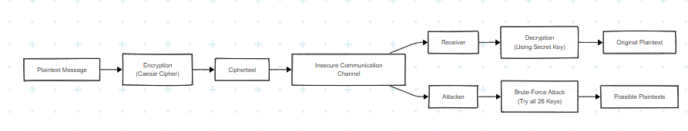

4.1 Entities Involved
- Sender – Encrypts the plaintext message
- Receiver – Decrypts the ciphertext using the same key
- Attacker – Performs brute-force attack on intercepted ciphertext

4.2 Communication Flow
Sender → Encrypted Message → Receiver
Attacker → Intercepts Ciphertext → Tries all possible keys

4.3 Network Assumption
- Sender, receiver, and attacker are assumed to be on the same network
- The communication channel is insecure

5. Mathematical / Cryptographic Background

- Caesar Cipher – A substitution cipher where each letter is shifted by a fixed number
- Encryption Formula:
C=(P+K) mod 26C = (P + K) mod 26= (P+K)mod26
- Decryption Formula:
P=(C−K) mod 26P = (C - K) mod 26= (C−K)mod26
- Key Space – Total possible keys = 26
- Brute Force Attack – Trying all possible keys until meaningful plaintext is obtained

6. Data Flow Description

- User enters plaintext message
- User provides shift key
- Plaintext is encrypted using Caesar Cipher
- Ciphertext is generated and transmitted
- Receiver decrypts ciphertext using same key
- Attacker tries all 26 keys to recover plaintext

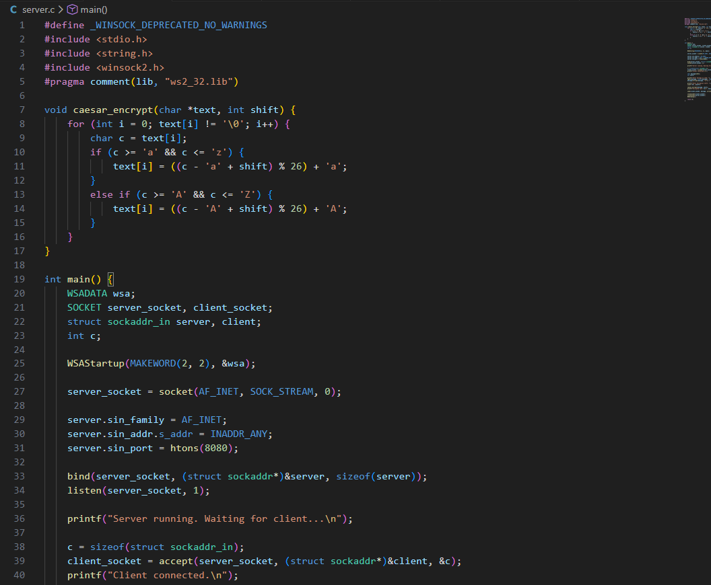
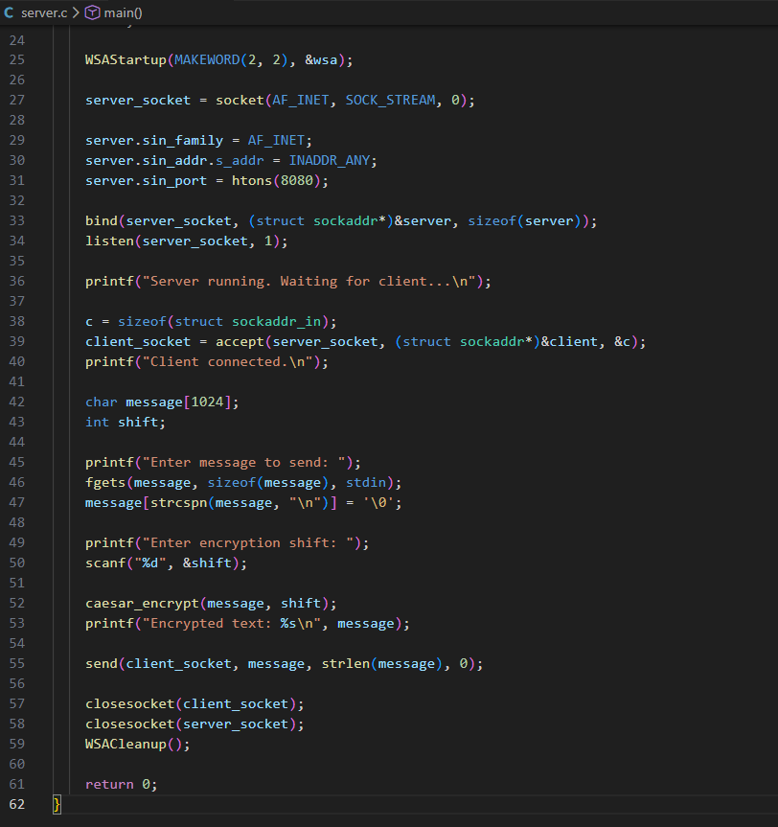

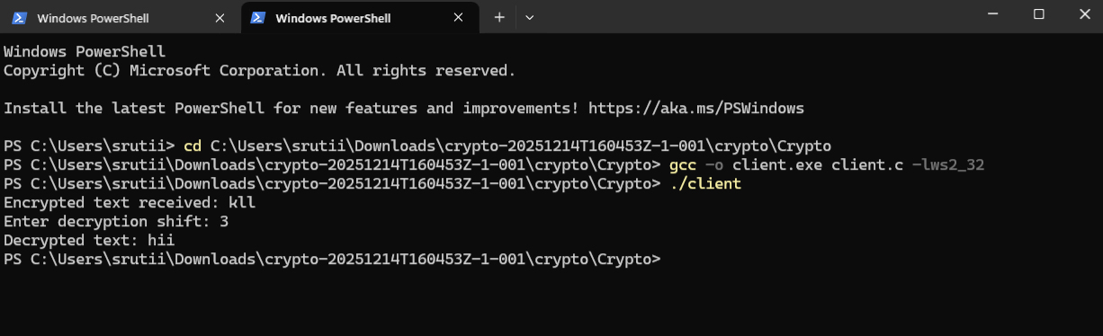

7. Threat Model

Type of Attacker: Passive attacker
Attack Capability: Can intercept an encrypted message
Knowledge Available to Attacker:
- Encryption algorithm
- Ciphertext
Unknown: Secret key
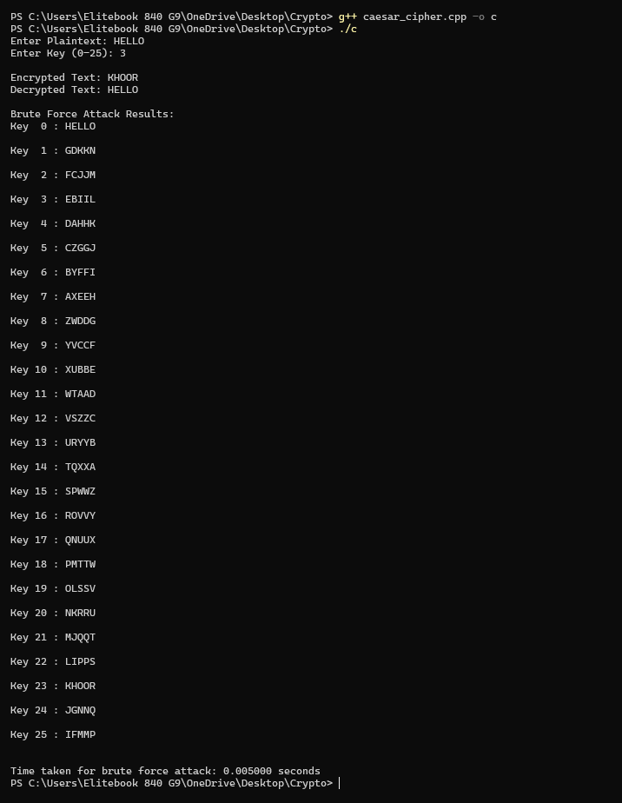
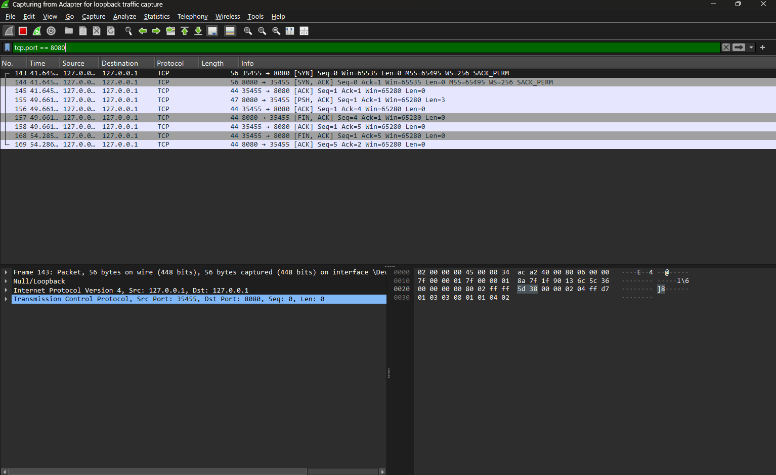


8. Attack Type

- Brute-Force Attack
- Weak Key Space Exploitation
- Classical Cryptographic Attack

9. Security Goal
Security Property | Status
Confidentiality | Broken
Integrity | Not Affected
Availability | Not Affected
Authentication | Weak

10. Prevention Mechanism and Security Reinforcement
The objective of the prevention mechanism is to eliminate the identified security weakness exploited during the attack and to restore the intended security goals of the system.

10.1 System State Before Prevention (Identified Weakness)
- Very small key space (26 keys)
- Predictable substitution pattern
- No randomness
- Easy brute-force attack

10.2 Applied Prevention Measures
- Use larger key size
- Use modern encryption algorithms
- Introduce randomness and complex transformations
- Avoid simple substitution ciphers

10.3 Implementation Details
- Programming Language: C
- Functions Implemented:
  - Encryption
  - Decryption
  - Brute-force attack
  - Time measurement

Test Cases
Test Case | Input | Expected Output | Observed Output
TC1 | Plaintext + Key | Encrypted Text | ✔
TC2 | Ciphertext + Key | Original Text | ✔
TC3 | Ciphertext | All Possible Plaintexts | ✔

12. Results and Analysis

12.1 Observed Results

Encryption and decryption work correctly

Brute-force attack successfully retrieves plaintext

Time required is very small due to limited key space

12.2 Result Table
Parameter | Weak System
Cipher Type | Caesar Cipher
Key Space | 26
Attack Feasibility | Easy
Time Required | Very Low
Security Level | Poor

Graph 1: Key Space Size Comparison

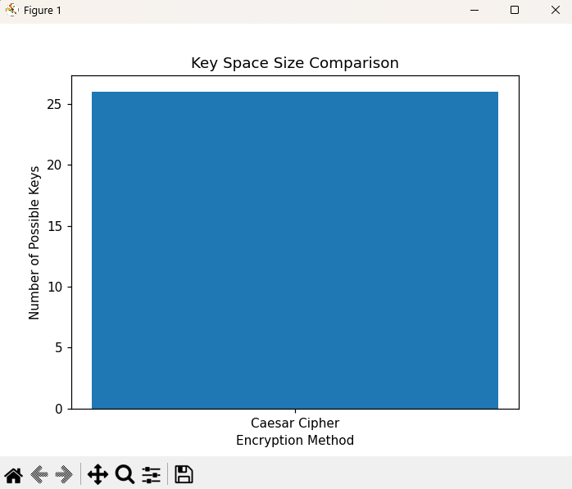

Graph 2: Attack Success Rate vs Parameter Size

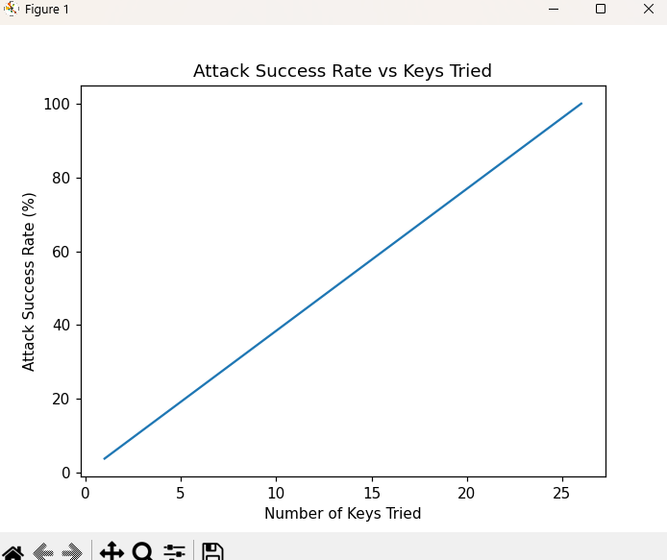

Observation:
As parameter size increases, attack success rate decreases.

Graph 3: Time Required to Break Security
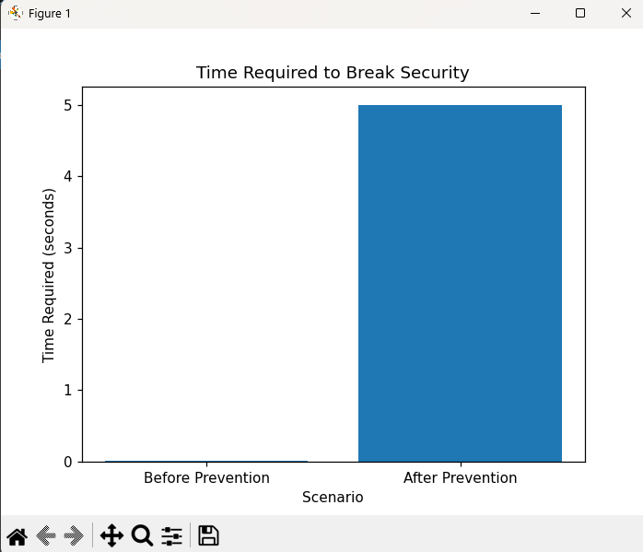

Observation:
Breaking time increases sharply after prevention.

13. References

Purpose:
Academic discipline

Allowed:
- Textbooks
- NPTEL
- RFCs
- Standard crypto books

Example:
- William Stallings – Cryptography and Network Security
- NPTEL CNS Lectures
- RFC 4107

